

**Operating System**

**Lab # 09**

**Name: Zainab Bibi**

**Sap Id: 46462**

**Batch: BSCS 5thsemester**

**Submitted to: Mam Kausar**

**Q1**

Run following script. And examine output.  **01**

#!/bin/sh

clear

date > lab9

echo -e "lab9 file contains:"

cat < lab9

**Answer:**

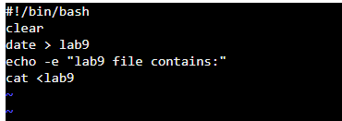

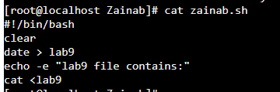

**Q2.**

A file contains following script. Execute this code

#!/bin/sh

clear

x=5

y=0

echo "The value of X = " $x

y=$(expr $x + 5)

echo "The value of Y = " $y

**Answer:**

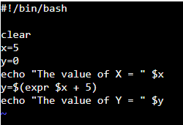



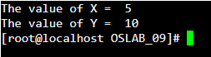

**Q3.**

Write shell script that reads 2 integer values from user and print their sum on screen. **Answer:**

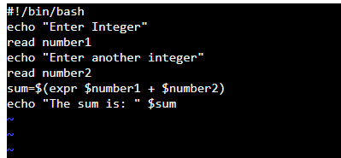

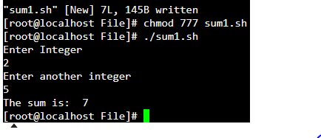

**Q4.**

Write shell script that takes string from user, and make folder with named with string. Folder should contain file with named timestamp. Having current time and date written on it.

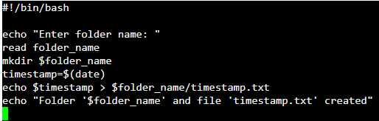 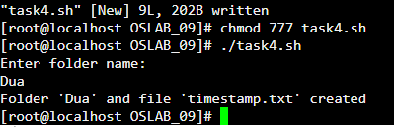

**Q5.**

Write a shell script to get the total count of the word “Linux” in all the “.txt” files and also across files present in subdirectories.

**Answer:**

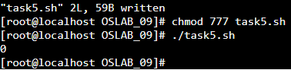

**Q6.**

Write shell script that defines 2 integers and one float value like

a=5

b=7

c=5.5

Perform multiplication of integers then divide with float.

and finally print result with four decimal places. like 6.3636

you have to use pipe operator ( | ) to send variables to bc utility for arithmetic. **Answer:**

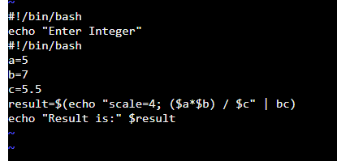

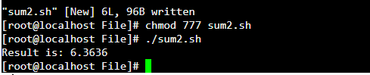

**THE END**